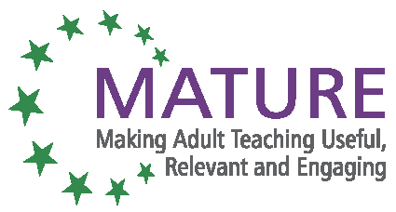

MATURE Dissemination List – (RF007)
Organisation name: Zveza društev upokojencev Slovenije

Quarterly report number: 7 Reporting period: 01/04/2014 – 30/06/2014

Date | Type of Activity | Short description | Nº individuals / organisations  concerned | Evidence available?
15. 4. 2014 | Written article | Article titled MATURE – Naj bo učenje odraslih koristno, pomembno in mikavno – general description about project initiatives with link to research report and project webpage, published in e-newsletter of Institute for Adult Education and also in Eurydice Slovenia | 2.249 recipients | http://arhiv.acs.si/e-novicke/2014/april.pdf  http://www.eurydice.si/index.php?option=com_content&  view=article&id=8704&Itemid=999
28. 4. 2014 | Written article | Short article, titled MATURE – Zgodba iz Sv. Tomaža, a case study that will be in the advice booklet, published in the newsletter ZDUS plus, edition April 2014, page 19 | 5.000 printed copies + online edition | http://www.zdus-zveza.si/file.php?t=zdusplus&id=23  (page 19)
29. 04. 2014 | Written article | Article – Story from St Tomaž – how we engaged retired and older unemployed people (example from advice booklet), published on ZDUS website | 7 | http://www.zdus-zveza.si/zgodba-iz-svetega-tomaza-kako-smo-aktivirali-upokojence-in-starejse-brezposelne-copy
May 2014 | Written article | Short article, titled MATURE – Zgodba iz Sv. Tomaža, a case study that will be in the advice booklet, published in the magazine for the elderly Vzajemnost, edition May 2014, page 219 | 30.370 printed issues | Copy of the article from the magazine

Signature: (Manager) Date signed: 03. 07. 2014

