Introduction
“Education is no longer a one-time event but a lifelong experience. Education should be less passive listening (no long lectures) and more active doing. Education should empower students to succeed not just in school but in life.” https://www.udacity.com/us

“New skills and knowledge makes you a more valuable employee, whether working for yourself, for an employer, or future employer. With today’s workplace changing faster than ever, it is essential everyone keeps learning new and updating old skills to remain or become competitive in the workplace. ALISON is for anyone taking their first step to a new or better job. ALISON is as individual as you are.” http://alison.com/subsection/?section=about

Two example definitions of MOOC
“A massive open online course (MOOC) is an online course aimed at unlimited participation and open access via the web. In addition to traditional course materials such as filmed lectures, readings and problem sets, many MOOCs provide interactive user forums to support community interactions between students, professors, and teaching assistants (TAs). MOOCs are a recent development in distance education which was first introduced in 2008 and emerged as a popular mode of learning in 2012.” [1]
“Online courses designed for large numbers of participants that can be accessed by anyone anywhere as long as they have an internet connection, are open to everyone without entry qualifications, and offer a full/complete course experience online for free”. In Europe according to the results of the survey there is a strong support of this definition [2].

The beginning of MOOCs
Massive Open Online Courses (MOOCs) started in Canada and the US. They have received considerable media coverage since the beginning of 2012. Their rise of recognition was supported by the well know service providers such as Udacity, Coursera and Edx.
MOOCs appeared in Europe in 2013. They started with the pan-European initiative OpenupEd and different (regional) MOOC platforms as FutureLearn, Iversity, FUN, UNEDcoma, Miríada X. In September 2013, the European Commission launched the initiative Opening Up Education to further enhance the uptake of Open Education in Europe (European Commission, 2013). Recently the European Commission funded a number of MOOC projects for example EMMA.

Example results of surveys about MOOCs
From July 24, 2012, through Sept. 21, 2014, an average of 1,300 new participants joined a HarvardX or MITx course each day, for a total of 1 million unique participants and 1.7 million total participants. With the increase in second and third versions of courses, the researchers found that participation in second versions declined by 43 percent, while there was stable participation between versions two and three. There were outliers, such as the HarvardX course CS50x (Introduction to Computer Science), which doubled in size, perhaps due to increased student flexibility: Students in this course could participate over a yearlong period at their own pace, and complete at any time. To summarise the survey the following statements were formulated:
- Participation in repeated courses has declined and then stabilized.
- A slight majority of MOOC takers are seeking certification, and many participants are teachers.
- Academic areas matter when it comes to participation, certification, and course networks.
- Those opting for fee-based ID-verified certificates certify at higher rates.
Hollands & Tirthali (2014) reviewed literature and interviewed 83 individuals of 62 US institutions about MOOCs. They report a variety of institutional goals, which fell into one of six categories:
- extending the reach of the institution and access to education
- building and maintaining brand
- improving economics by lowering costs or increasing revenues
- improving educational outcomes for MOOC participants and on-campus students
- innovation in teaching and learning
- conducting research on teaching and learning

Recommended links
Name | URL
Udacity | https://www.udacity.com/
Coursera | http://coursera.org/
Edx | https://www.edx.org/
M4T | http://moodle4teachers.org/
EMMA | http://project.europeanmoocs.eu/
Alison | http://alison.com/
W3Schools | http://www.w3schools.com/
Neuronal Dynamics | http://neuronaldynamics.epfl.ch/

Summary
MOOCs are a new form which helps to educate many people and provide a solution to the increasing need for an affordable higher education. By using ICT for digitalizing education content, enabling mass distribution and personalized learning they also support reducing costs of education. Flexible, innovative learning approaches and user friendly delivery methods could help to improve the quality and relevance of higher education. MOOCs support transversal competences, e-skills for the digital era, creativity and flexibility and a solid understanding of the chosen field and finally they help finding jobs [2].
More information regarding massive open online courses (MOOCs) and other forms of open educational resources (OERs) can be found in [3].
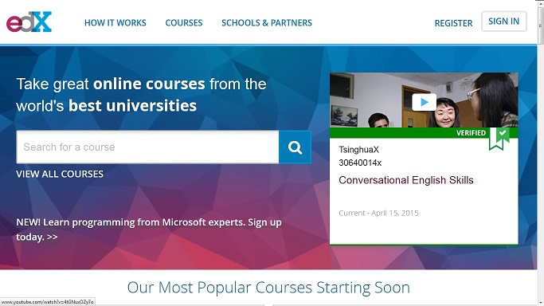

Resources
[1] http://en.wikipedia.org/wiki/Massive_open_online_course,
[2] Institutional MOOC strategies in Europe, Status report based on a mapping survey
conducted in October - December 2014, EADTU, February 2015 http://www.eadtu.eu/documents/Publications/OEenM/Institutional_MOOC_strategies_in_Europe.pdf
[3] MOOCs and Open Education Around the World, edited by Curtis J. Bonk, Mimi M. Lee, Thomas C. Reeves, Thomas H. Reynolds, MOOCs and Open Education Around the World Paperback – March 17, 2015, http://openworldbooks.com/moocs-book.php

