Output O3
Guidelines for consultants/enterprises

Activity leader: PRO-MED sp. z o. o.
Date of delivery: 2.04.2016

Executive summary
This deliverable contains guidelines for consultants (enterprises) who are users of the SP4CE portal. It provides an overview of the portal and gives particular instructions on how to use it. Portal and Learning Rooms usage scenarios approach is used in order to explain how to navigate, where and how to send a project proposal, how to gather ideas for problems to be solved, how to register as a consultant in Learning Rooms, how to communicate with students, etc.

Content
- About portal SP4CE
- How to use SP4CE portal
- Portal usage scenarios
- Learning Rooms usage scenarios

- About portal SP4CE
The main purpose of the portal SP4CE is addressing aims and needs identified in Bruges Communiqué on enhanced European cooperation in vocational education and training, especially "improving the quality and efficiency of vet and enhancing its attractiveness and relevance" and "enhancing creativity, innovation and entrepreneurship"
SP4CE portal provides the space for problems to be solved, questions to be answered. Within the project the enterprises will publish them. It supports not only individual work towards the problem solution but also creation of groups. In the portal mentoring and coaching approaches are implemented. It means that teams get support provided by mentors (from among trainers staff) and coaches (from among the enterprises staff). The portal enables also presentation of developed solutions and publishing of the chosen one.
There are following benefits of the portal usage :
- Enabling repository of the accepted and implemented solutions to the various problems available to general public.
- Supporting an international cooperation towards the solutions to various problems in 5 languages, including English.
- Encouraging young people to work as designers, inventors, and creators.
- Supporting of sense of initiative and entrepreneurship.
- Improving levels of skills for employability of students.
- Introducing new learning and cooperation methods implemented into daily activities of enterprises.
- Increasing opportunities for professional development of all target groups.
- Increasing labour market relevance of learning provision and qualifications and reinforcing links between education, training or the youth fields with the world of work.
- Promoting take-up of innovative practices in education, training and youth by supporting personalised learning approaches, collaborative learning and critical thinking, strategic use of Information and CT, Open Educational Resources (OER), open and flexible learning, virtual mobility and other innovative learning methods,
- Enhancing the professional development of those working or active in the education, training and youth fields by innovating and increasing the quality and range of initial and continuing training, including new pedagogies, ICT-based methodologies and use of OER.
- How to use SP4CE portal

  - Send us your project proposal
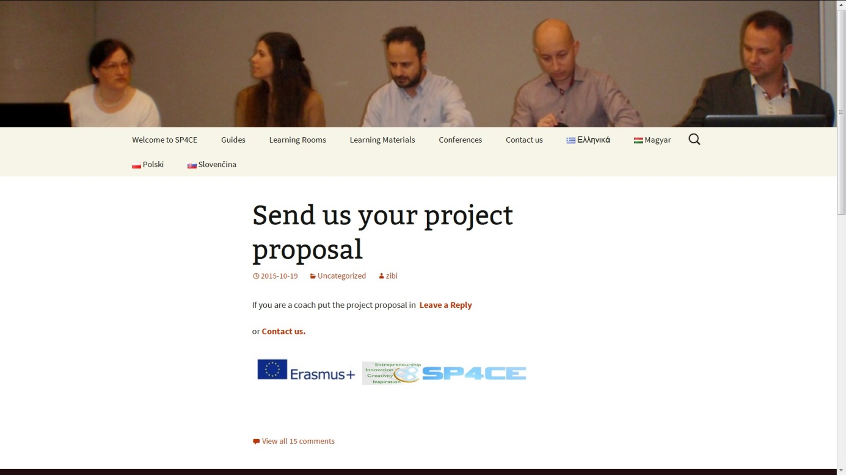
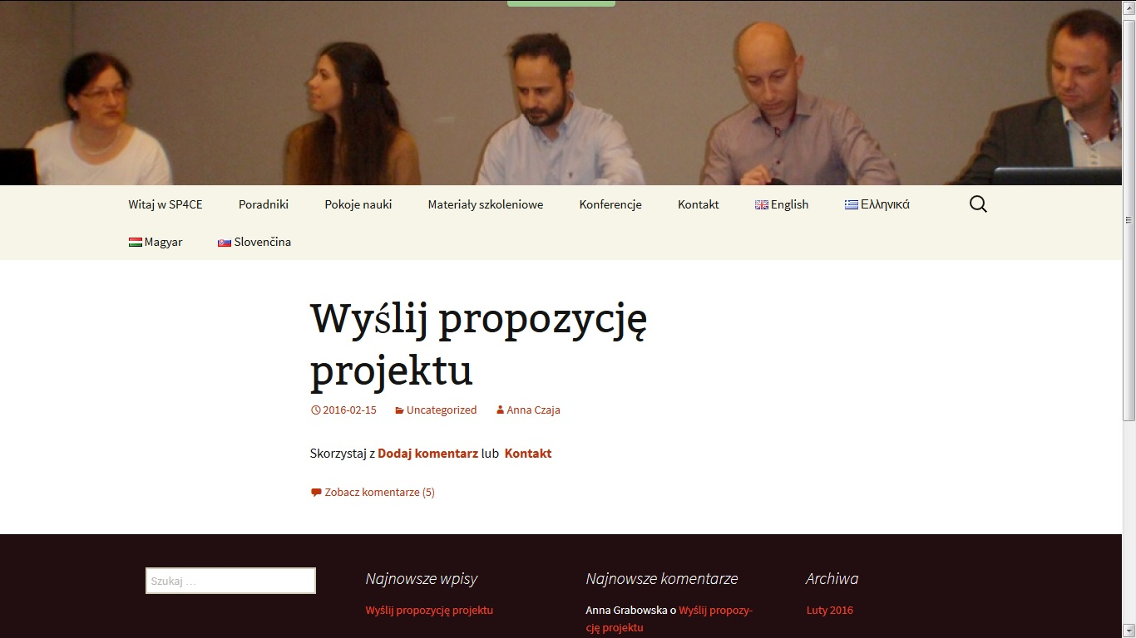
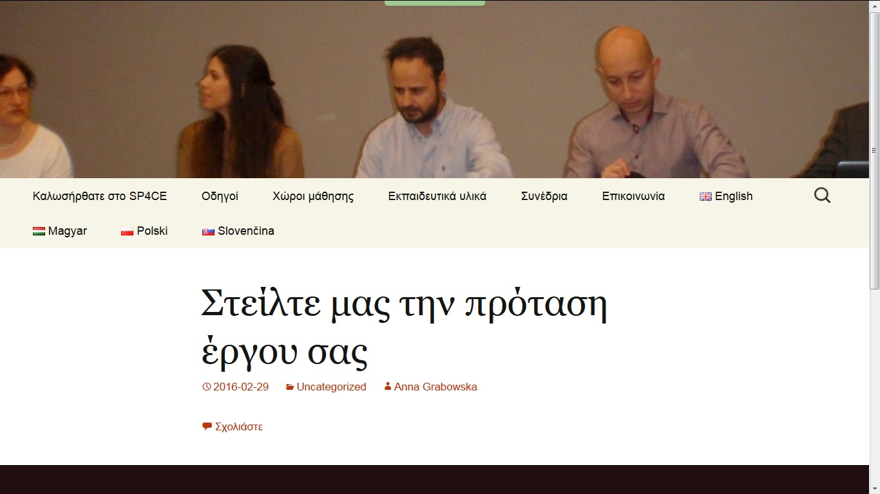

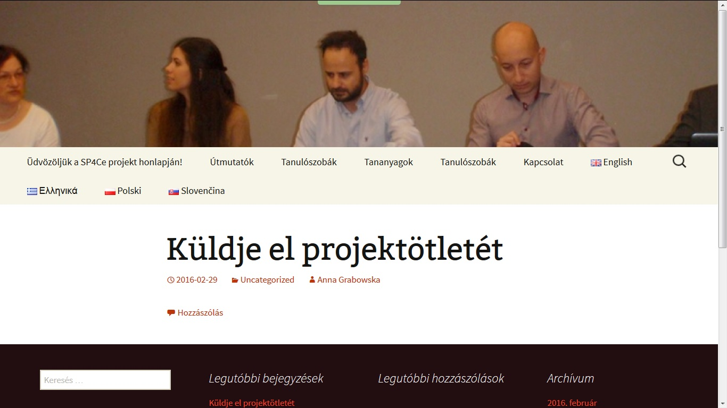
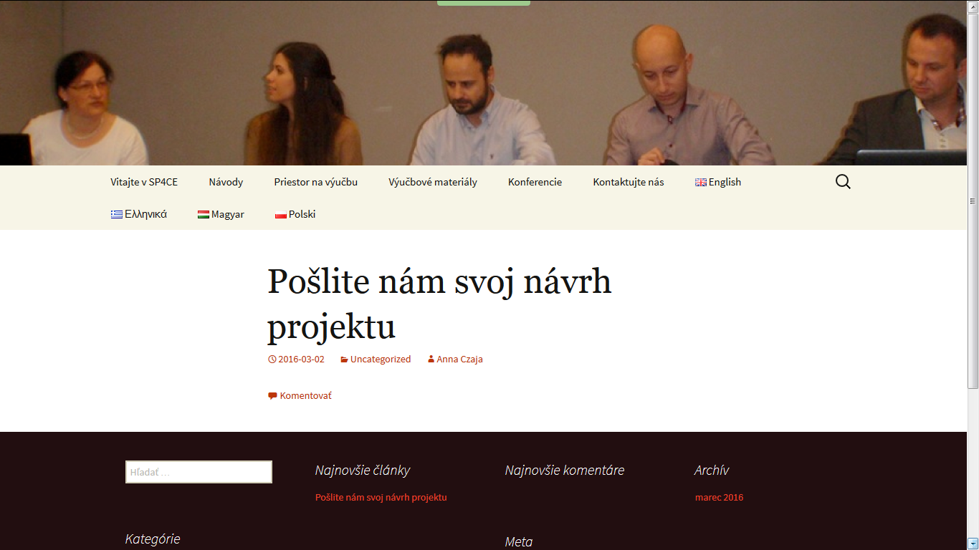

  - Welcome to SP4CE
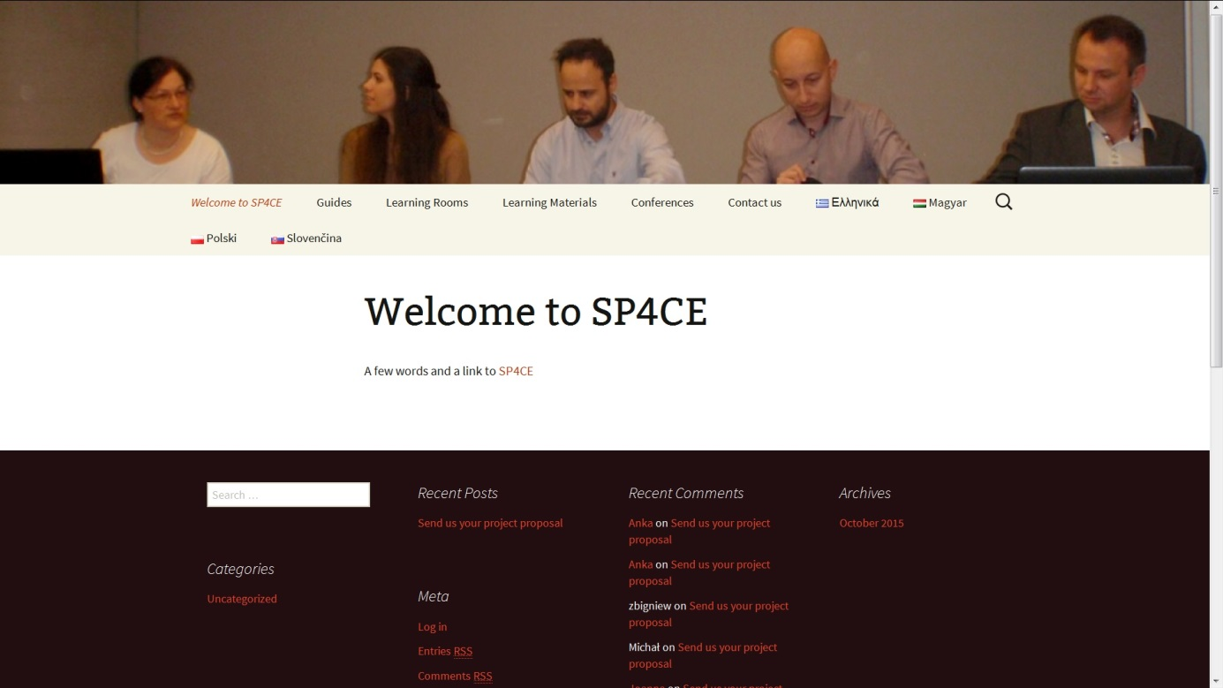

  - Guides

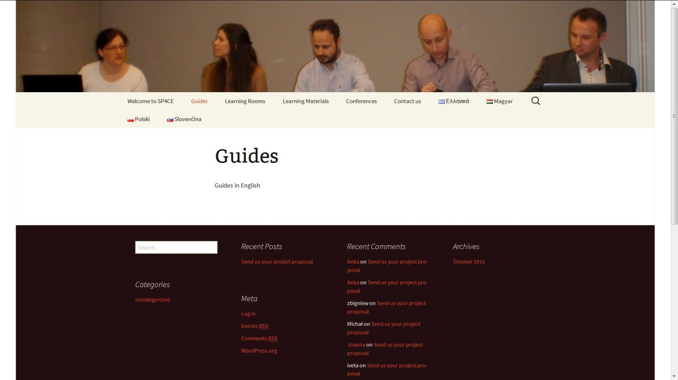

  - Learning Rooms
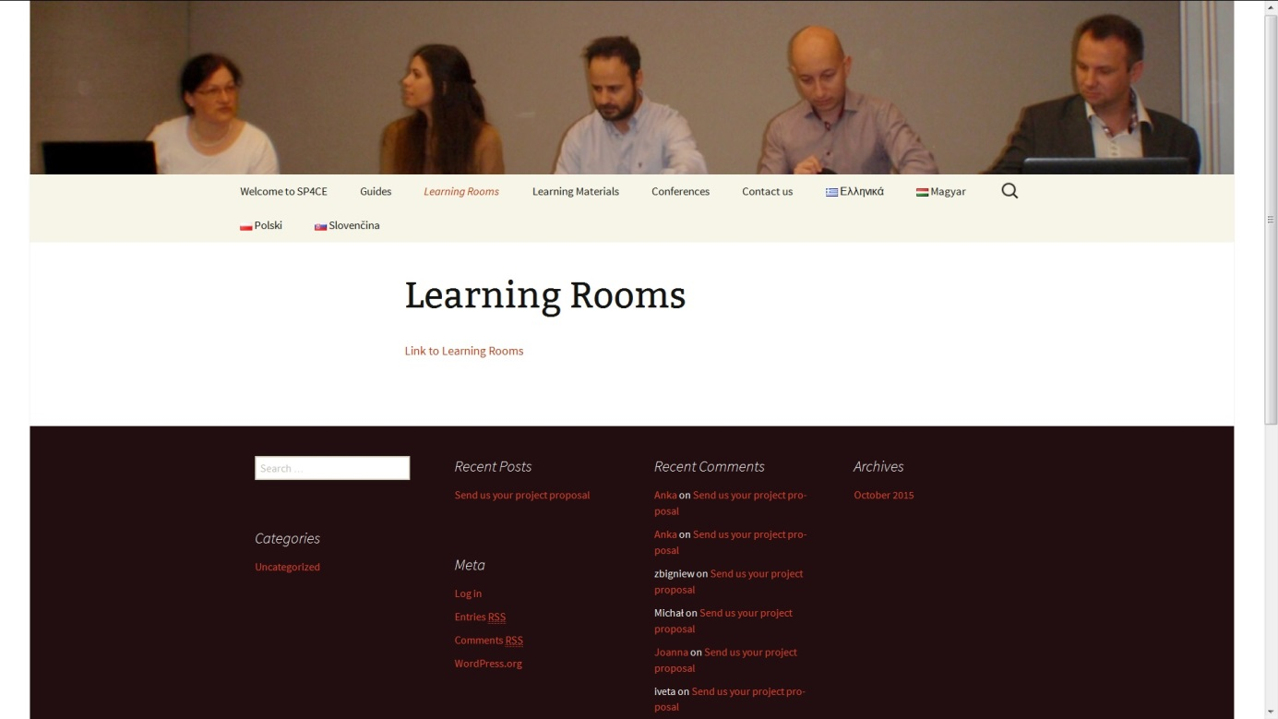

  - Learning Materials
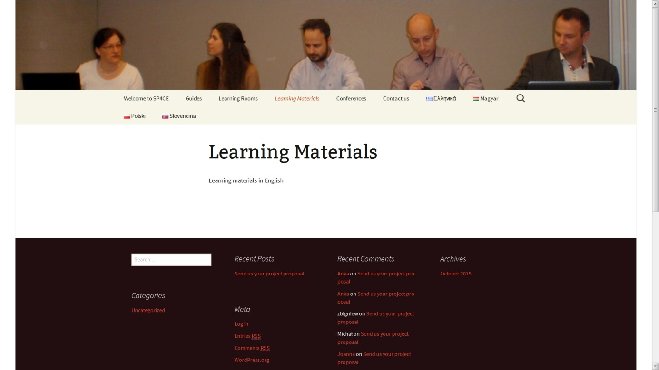

  - Conferences
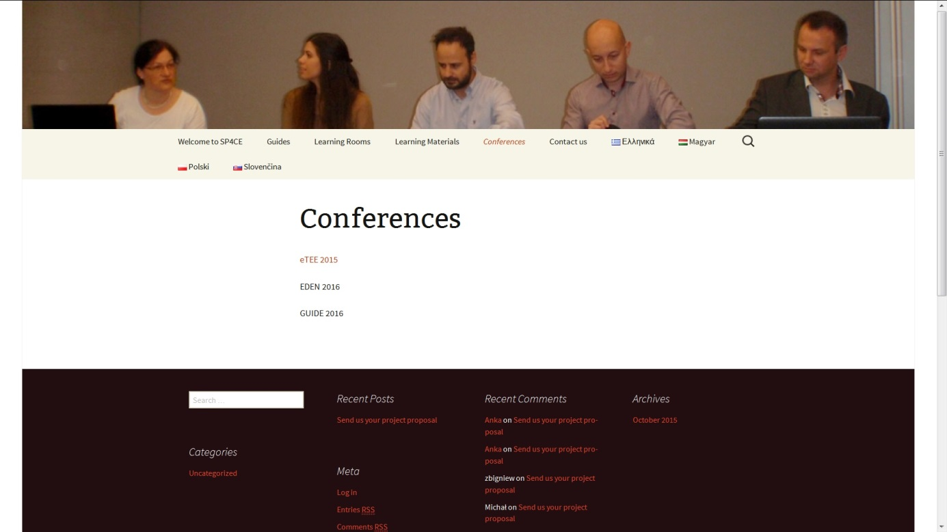

  - Contact
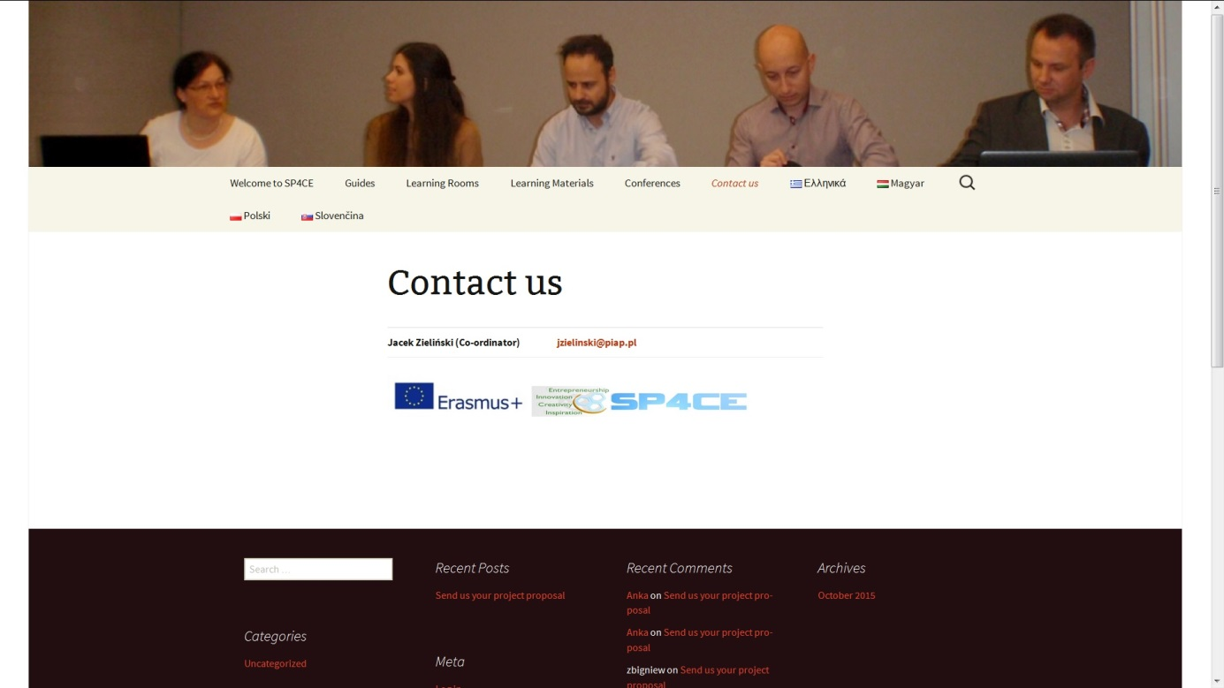

- Portal usage scenarios
If you are a coach you can put the project proposal in Leave a Reply (Fig.) or you can Contact us (Fig.).
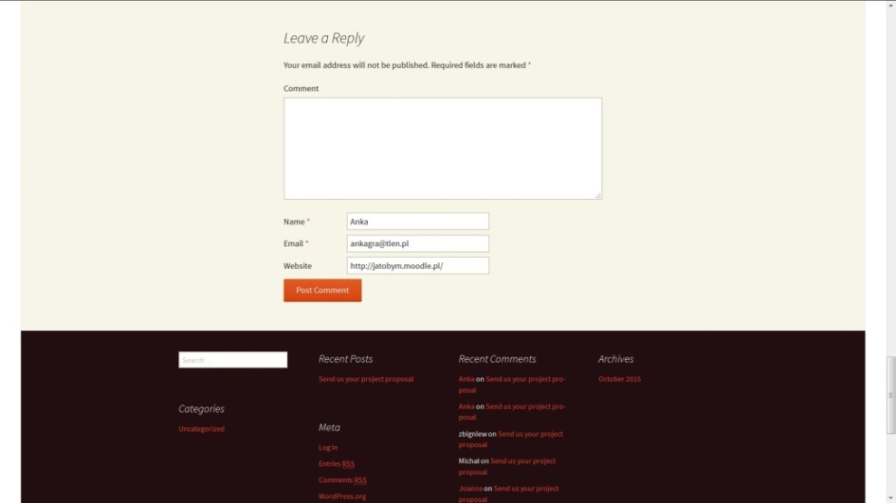
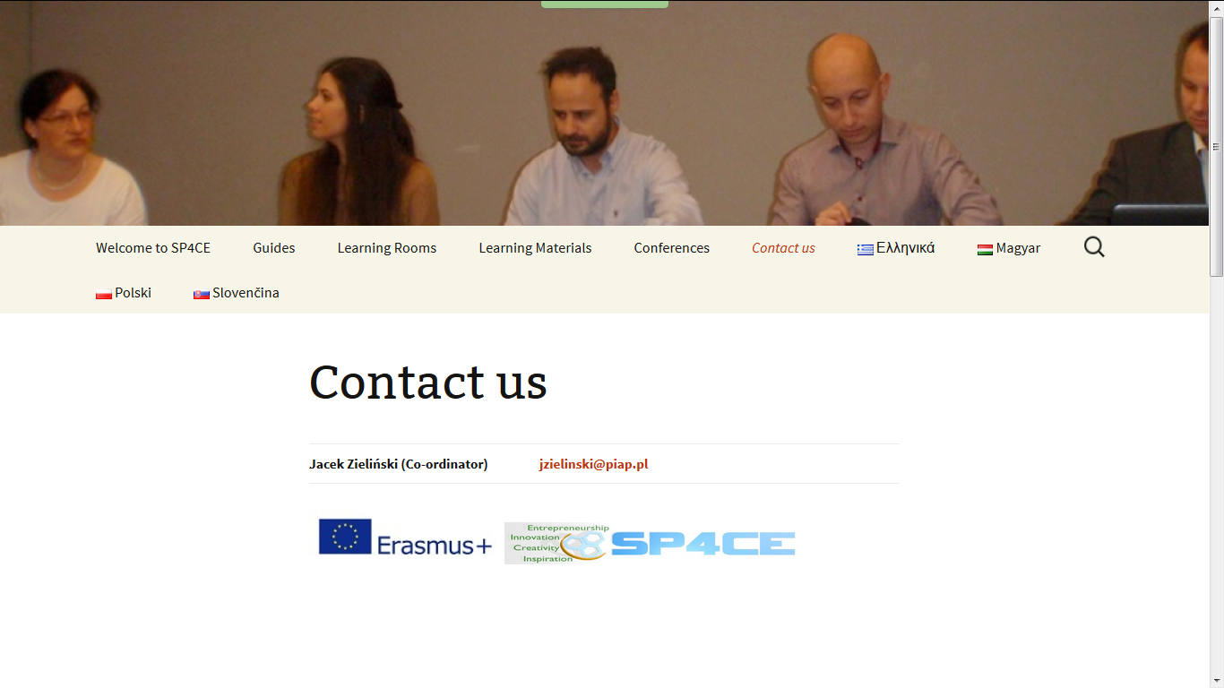
- Learning Rooms usage scenarios

