Learning Rooms in SP4CE - implementation and evaluation
Ewa Kozłowska, Gdańsk University of Technology, Poland

About project
SP4CE stands for the Strategic Partnership for Creativity and Entrepreneurship project. It has been funded with support from the European Commission under the ERASMUS+ Programme. The project started on 1st September 2015 and will end on 31st August 2017.
The main purpose of the project is to design innovative common e-learning tools for collaboration between students, enterprises and teachers. It concentrates on identifying needs of end users and supporting the development of relations between them by mentoring and consulting activities. Those tools are available as ICT solution with WWW interface designed for use in three main target groups: Coaches, Mentors and Students.

Assumptions and actions
- Problems to be solved, questions to be answered
- Creation of the teams which want to work towards the problem solution
- Work for teams or individuals to develop the solution
- Mentoring & coaching
- Presentation of developed solutions
- Publishing of the chosen solution
All project results and project actions will be connected with promoting take-up of innovative practices in education, training by supporting personalised learning approaches, collaborative learning and critical thinking, strategic use of Information and Communication Technologies (ICT), Open Educational Resources (OER), open and flexible learning, virtual mobility and other innovative learning methods.
Project partners identify problems with lack of trainings increasing competence of students in areas needed by enterprises and lack of innovative solutions for student-teacher-enterprises collaboration in vocational and high education trainings. Our answer is multi-user platform for common approach.
Project Strategic Partnership for Creativity and Entrepreneurship addresses directly aims and needs identified on enhanced European cooperation in vocational education and training, especially in the areas of:
- Improving the quality and efficiency of vet and enhancing its attractiveness and relevance.
- Enhancing creativity, innovation and entrepreneurship.

Project partners
- PIAP (project leader) is a research institute and has rich experience from coordination and participation in several different vocational education and research projects, additionally PIAP has experience from collaboration with industry enterprises and educational institutions.
- TUKE as technical university dealing with university teaching and international cooperation in the area of research and education, fostering links with institutions in private and public sectors and thus responding to their needs and to the needs of society in general.
- PRO-MED has experience from developing an innovative approach to teaching and learning based on e-learning and blended leaning methodology, building the common vision for LifeLong Learning in European countries, collecting and implementing different methods used for educating the staff and learners, discovering methods of promoting access and increasing participation in Lifelong Learning for the staff and learners, gathering flexible education and training methods and approaches for creation a culture of learning.
- ASTRA has significant experience in conducting trainings for managers, has good contacts with other training institutions and already participated in several international research and educational projects.
- TREBAG has rich experience from development of innovative training materials and methodologies including e-learning (e.g. related to vocational training) and implementation of technology transfer and innovation chain management as well as technology transfers.
- IDEC has extensive experience in European projects, either as coordinator or as partner from different European programs and Initiatives. IDEC has consulting experience in developing quality management systems in Greek training centers.

The proposed solution - SP4CE Learning Portal in WordPress and SP4CE Learning Rooms in Moodle
The multilingual learning portal was created in WordPress and is available at: http://sp4ce.eu/.
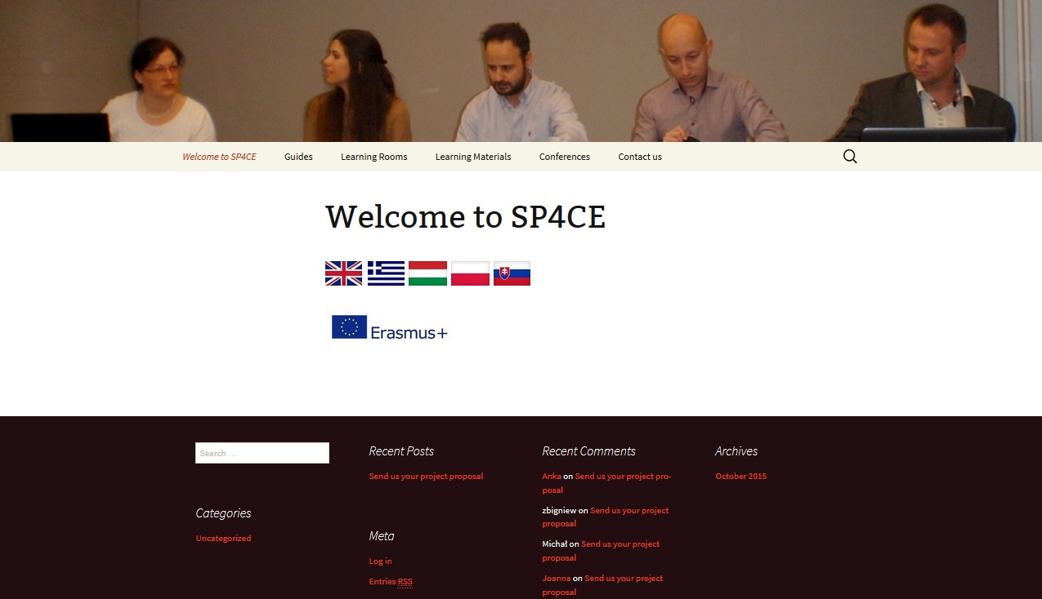
Figure 1 SP4CE learning portal - homepage. [2]
Eleven Learning Rooms were created and they were the subject of the 1st evaluation. Each partner has been given at least one Learning Room in English. It was also possible to work in a local language (Greek, Hungarian, Polish and Slovak).
Students were able to make a self-enrolment into the chosen Learning Rooms. The following tools were offered: forum, chat, wiki, the space for supported materials. There was also a possibility to add an extra tool to make the cooperation more comfortable for each target group.

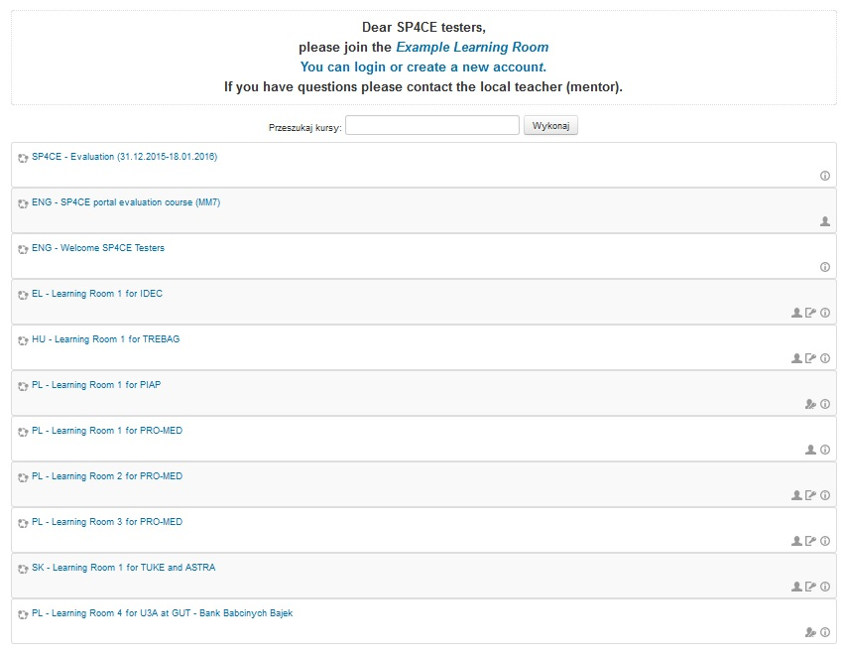
Figure 2 SP4CE learning rooms on moodle. [3].
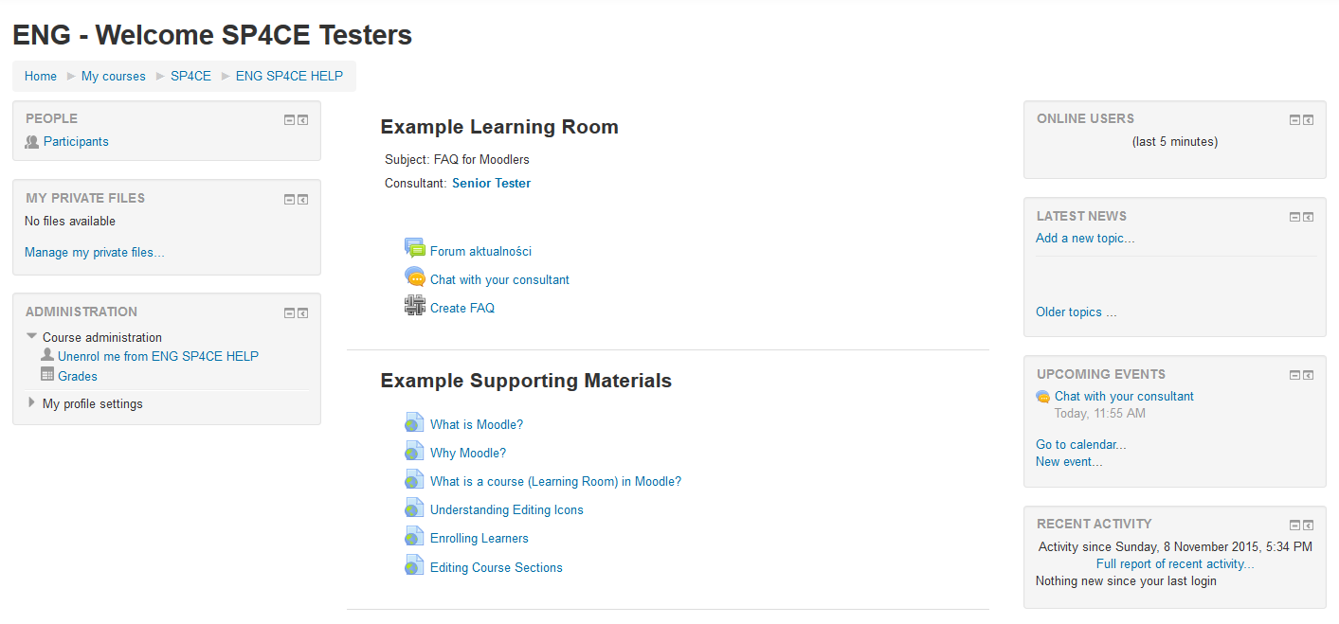 Figure 3 Example learning room. [3]

Project evaluation
In order to evaluate the actual project progression the participant were asked to fill in the questionnaire prepared by PRO-MED. The Feedback Questionnaire objectives were following: to obtain the participants opinion on SP4CE portal itself – its design, usability, functionality - what was missed and what needs to be added, and also to obtain the participants opinion on tools for collaboration - what was missed and what needs to be added.
The Feedback Questionnaire was filled in by 16 SP4CE participants from 4 countries. The results have been developed using tables and graphs and will be presented during the conference.

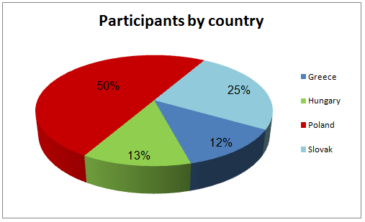
Figure 4 Participants by country

References
Webpages
- Official SP4CE webpage: http://sp4ce.piap.pl/index.php
- SP4CE learning portal: http://sp4ce.eu/
- SP4CE learning rooms on moodle: http://jatobym.moodle.pl/course/index.php?categoryid=3
- PIAP: http://www.piap.pl/
- TUKE: http://www.tuke.sk/
- PRO-MED: http://www.pro-med.org.pl/
- ASTRA: http://www.astra-ngo.sk/index.php/en/
- TREBAG: http://www.trebag.hu/
- IDEC: http://www.idec.gr/

