FAMOUS GEOGRAPHER PHILIPP CLÜVER (1580 -1622)
WHO CREATE THE CONTEMPORARY BORDERS OF EUROPE

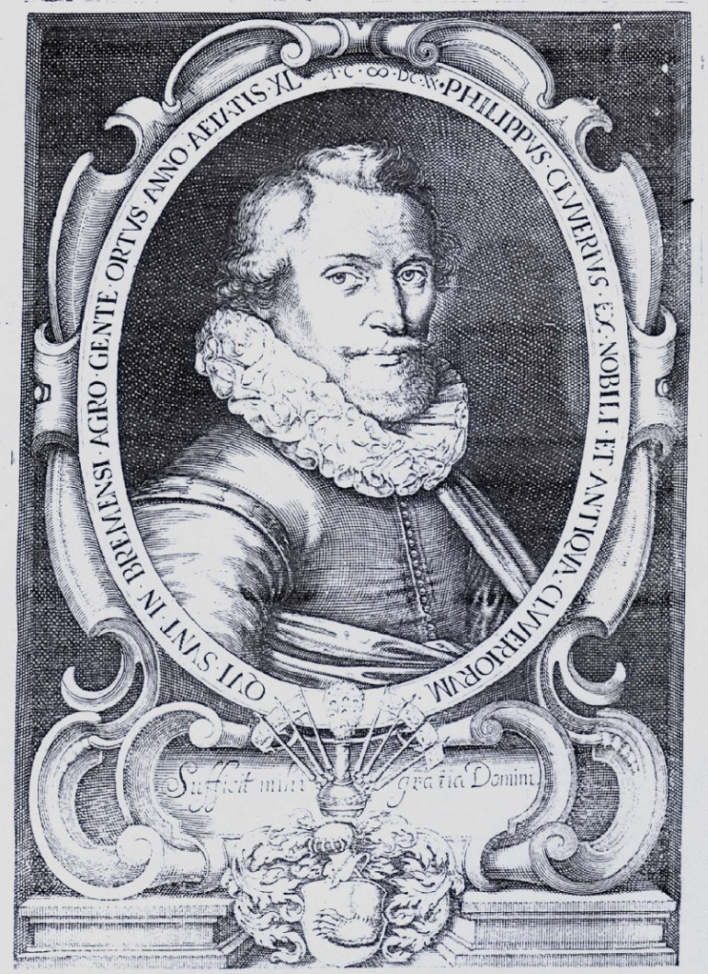

The year 2016 will be dedicated to the 400-year anniversary of Europe in its contemporary borders set as far as at the Ural Mountains (“Rhymnicos monteis”). These borders were first marked in 1616 on a new map of Europe published by Philipp Clüver, a famous geographer and cartographer originating from Gdańsk, professor of the Leiden University (Holland).

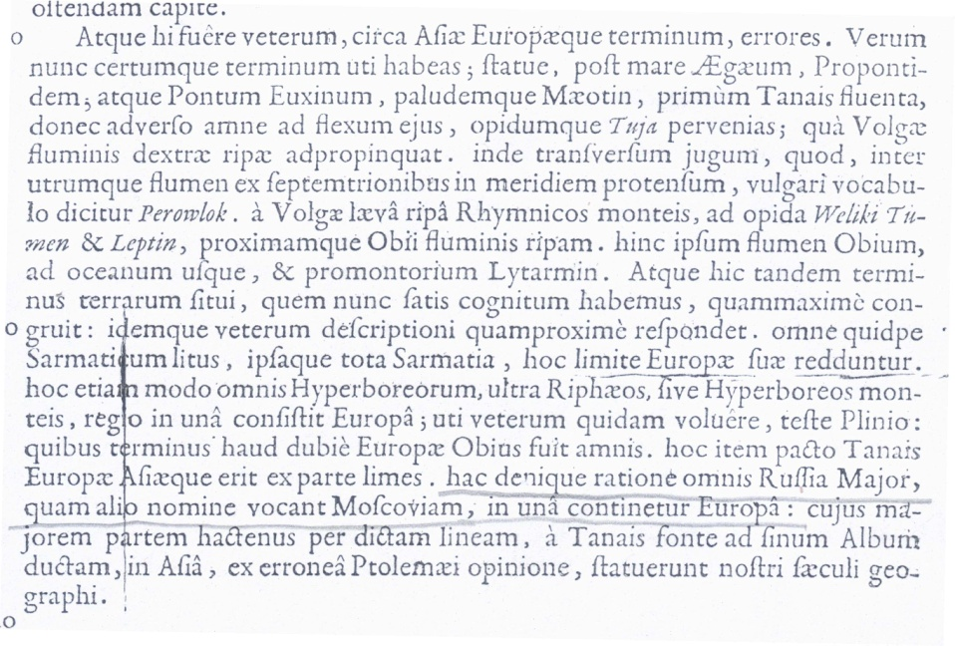

Germania antiqua libri III. L. Elzewiri, Lugduni Batavorum 1616

