The Museum of Work – our collection of 3 stars
Done by participants from Sweden, Portugal, Poland
The Museum of Work shows working life and working conditions through exhibitions, seminars and programme activities. It is an innovative meeting place which promotes discussion on peoples work, lives and conditions. We visited the https://www.arbetetsmuseum.se/utstallning/sounds-of-changes/ and were inspired there by the EU Sounds of Changes project.
Here is a task for you: Please listen to our 3 stars recordings and guess who/what generated the sound. Are our photos located in a proper place?

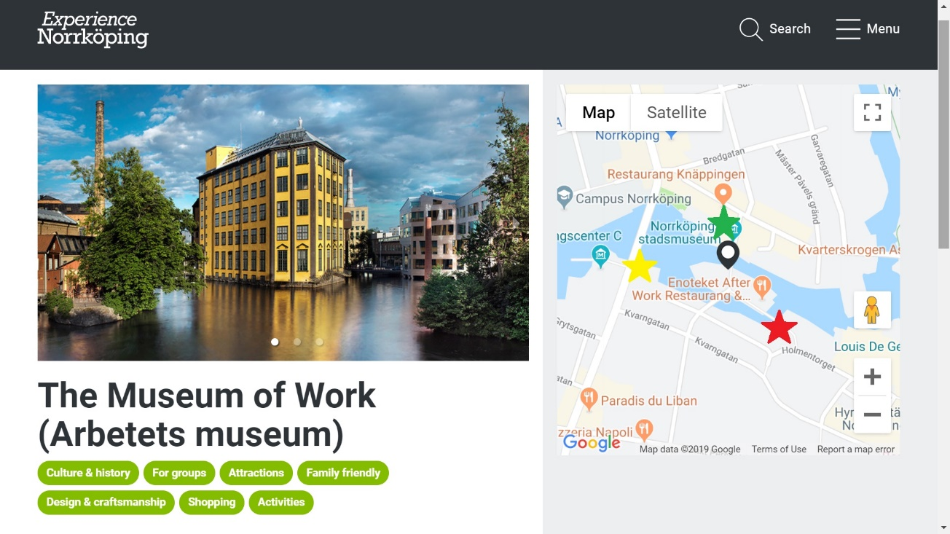

 | Sound 3 | 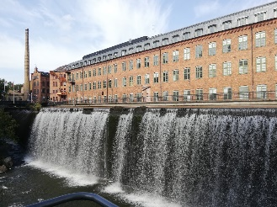
 | Sound 1 | 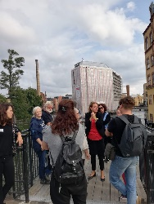
 | Sound 2 | 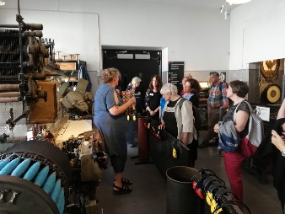

More sounds you can find at http://www.soundsofchanges.eu/

