Contents
1. Peer Mentoring Methodology 2
1.1. What is Peer Mentoring? 2
1.2. Who is a Peer Mentor? Personality – knowledge, skills, competences of Peer Mentor in the 21st century for 50+. What do you essentially have to know? 4
1.3. Roles of Peer Mentor – 10 Principles 8
1.4. Benefits of Peer Mentoring for Mentors and Mentee 13
1.5. Quiz 14
1.6. Literature 17
1.7. Annex 1 Quiz Answers 18

Peer Mentoring Methodology

What is Peer Mentoring?

Peer mentoring is a relationship between people who share some similarities (e.g., age), in which one person has more experience and/or different knowledge than the other in a particular domain thus providing learning support for knowledge and skills development. Peer mentoring may be a one-on-one relationship or experienced in a group. The exchange is usually mutual, even if one member of the dyad begins in the traditional role of mentee, or learner, and the other in the role of mentor. For example, a newcomer to an organisation may be the learner in one topic and be the mentor in another. This is common, for instance, in third age universities.

You are welcome to watch Matt MacLean in YouTube
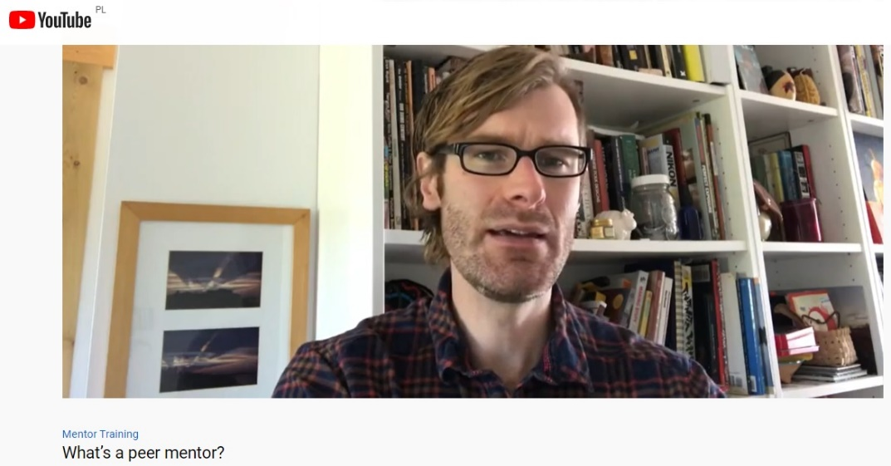

Read some sentences captured from the transcript:
… you're not a teacher you're not a therapist but more of a trusted advisor and you can also think of some of the important role models that you've had in your life what were they like what did they do that was helpful for you what kind of qualities did they possess…

… you're going to be listening you're going to be understanding you're going to get to know them you're going to collaborate with them on finding solutions to challenges you're going to use your experience to guide them you're going to share tips and tricks with them you're going to refer them to different resources…

…you know you're going to be meeting new people, you're going to learn about them, they may be teaching you things certainly they're going to have interests and skills that you don't have and so you'll, be able to take advantage of that and you're going to be gaining some leadership experience you're going to be building your cv so again it's this two-way relationship but still with you as the mentor being much more focused having to keep much more in mind in terms of making sure that the relationship is positive and to the benefit of the mentee…

Try to find similar films in your language, have a look at the example in Polish below:
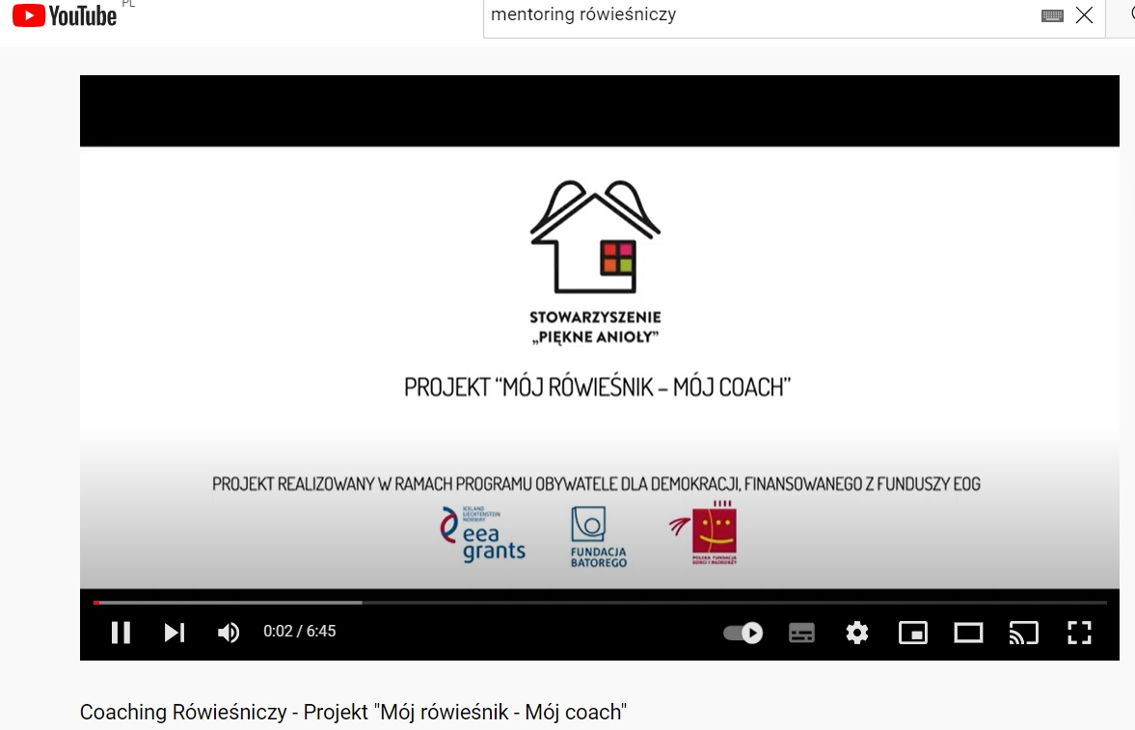

Who is a Peer Mentor? Personality – knowledge, skills, competences of Peer Mentor in the 21st century for 50+. What do you essentially have to know?

Can you play a role of a Peer Mentor?
If you are comfortable in your career it can be a good time to pay it back, you can inspire and guide others, you can start to become a mentor. Being a mentor provides an extremely important transfer of knowledge so that your mentees do not spend valuable time learning/doing what you have already knew/experienced. By being a mentor, you provide a concrete knowledge for mentees, so they can learn from your prior experience and they can make better decisions in similar scenarios.

What qualifications does a mentor need?
To be a mentor, it is essential to have experience in the area you are mentoring someone in. You are not able to teach well if you have not experienced, learned from practice and applied the same principles yourself.
It is also important to have people skills and the ability to teach at an individual level. You need to be able to read a person to know whether a teaching approach is working. Sometimes, you just need to be a career coach. Other times, you have to be a listener and, sometimes, a source of practiced wisdom on how to avoid mistakes. To know which approach is the best, you have to be able to discuss the situation with the mentee and choose the best path forward to develop that person’s skills and careers.
To be an effective mentor, you need to have experience in the area you are mentoring someone in along with the ability to read the individual to understand what they need in order to help them choose the right path.

Why is it important to be a mentor?
Mentors are incredibly valuable, not just for providing guidance and training to a new person; they are also reassuring. A mentor has been the new kid on the block and understands the stresses and fears that come with that position. For this reason, they remember how they felt when they were in that position and are, therefore, able to guide another person through the journey.
Giving this reassurance, mentors can increase the confidence of mentees. Mentors also pass down their own wisdom and learning experiences. On the other hand it is important for a mentor to encourage mentees to think for themselves, giving them freedom and general framework for dealing with certain problems.

What makes a good mentor?
Some important features in a good mentor include patience and listening skills. The most effective mentors take part in what is happening, assess the path the mentee is on and then guide the person onto the right track. Mentoring is as much about counselling as it is transferring knowledge and leadership skills. That takes practice, and the mentor has to be willing to let the mentee make mistakes and try guiding them again.

Five ways to become a good mentor:
1. Communicate and listen.
Your mentee should ultimately oversee their own learning path. You help them achieve whatever it is they want to achieve/learn. Do not inject too much of your own desires or opinions into their plan. Ask them about their aspirations as well as their expectations of you. For example, are they looking for support, guidance or insight?
Make sure to target your approach. For instance, maybe you want to help someone who is experiencing a similar situation as you did, or perhaps you want to give someone opportunities they do not have access to.
Define what your mentee should get out of a mentoring relationship with you and why you want to mentor him/her. Thant to this approach you will able to set common expectations, agree on the goals of the relationship and maintain healthy boundaries.
If you and the mentee share your hopes and desires for the relationship, you will be able to establish a mutually valuable dynamic. Mentoring is not a one-sided conversation; it is an open discussion that encourages thoughts, questions and concerns.
This must also happen without judgment. If your mentee feels too insecure to ask a question, you need to find a way to earn their trust and build their confidence. Communication is 99% of a quality mentor-mentee relationship. If the two of you cannot clearly share ideas, thoughts, opinions and feedback, then it defeats the purpose of the relationship. A mentee needs to be able to confide in the mentor. Without this trust and effective communication, the relationship will not succeed.
It is important to understand a mentee’s challenges, goals, desires and feelings so that the mentor can best support, engage and encourage them.
2. Offer constructive criticism.
While you do not want to judge or offend your mentee, you should not filter your feedback to avoid hurting them, either. There is a way to deliver criticism without breaking their confidence. Sharing your experience is a great way to send a message without criticizing them directly. For example, tell them about a mistake you made and how you learned from it. If the mentee is perceptive, they will see the comparison and the subtle message: “Don’t do what I did, and here’s why.” The point is to educate, not tear down the person. Try to be diplomatic and tactful. Instead of noting only the mentee’s mistakes or shortcomings, point out something positive, and then offer guidance to improve their work. It is not possible to get everything right on the first attempt, so you need to be able to provide feedback constructively but effectively to ensure that they improve and progress.
If your mentee becomes sensitive or defensive, be as supportive as possible. Again, draw from your own experiences to explain a time you had a slip-up, or simply redirect their attention to the progress and achievements they’ve made thus far. Self-deprecating humor is powerful in disarming a defensive mentee and getting them to listen again.
3. Practice empathy.
It is important to relate to your mentees and understand their perspective and feelings. If they are having a bad day, you should pick up on their energy and work to help them through it.
Empathy is a crucial feature trait of a good mentor, you should be able to understand how your mentee is feeling and how to guide him or her.
You might think empathy cannot be taught, but with practice, you can achieve higher levels of empathy. This requires effort: listening more, being curious about others, appreciating those who are different from you, illuminating any innate judgments, and educating yourself to break false stigmas and ignorant notions.
For instance, you cannot expect everyone to progress at the same rate you did. You have different strengths, interests, backgrounds and experiences; be careful not to project immediate expectations onto your mentee. A common mistake mentors in very technical fields make is assuming a rising-star mentee in the same field will perform, think and act the same way as the mentor did. What might have been the challenge to pass for your generation may not be necessary or applicable now. Do not judge a mentee because they did not go through the same way you did to get a knowledge.
Times is changing, put aside your own feelings about how things were hard for you, you can speak far more clearly to someone who was able to avoid that challenge and still rise to the same role and expectations.
If the process is not helping, change and adapt it as you go, and include your mentee in decisions.
4. Let your mentee make decisions.
Because you think that you know better, it might be tempting to take the wheel. But this is not how your relationship should operate. As a mentor you should help a mentee learn their role, not to do it for them.
One of the most important skills the mentee needs to develop, with your guidance is creativity or common sense. Whatever you call it, your mentee has to be able to solve problems on the fly. Your role as a mentor is to help them develop those skills.
Try to think of yourself as a driving instructor. So you are re sitting in the passenger’s side, allowing your mentee full control of the journey. However, you are still there to offer advice and directions or to pull the emergency brake if needed.
It is recommended to add an element of autonomy once you have established a good relationship and trust level with your mentee. Give them some responsibility, and allow them to make their own decisions. This will encourage them to think for themselves and improve their confidence, showing you have faith in them.
If you believe in your mentees, and you make that clear to them by allowing them control, they will have much more faith in both you and themselves.
5. Work on becoming a positive role model
Mentees can learn a lot simply by observing and learning from the mentor words and actions. They can observe how the mentor behaves and interacts with others or a certain task at hand. If the mentor has a trouble with certain project, mentees can watch how to react to any obstacles that may come on a way.
To help your mentees to find the right path, show them multiple ways of handling difficult situations and talk them through the whole process. Let them know that they have a choice to how they react to failure. This can be talking to their mentor when they made a mistake or failed a task. Thanks to your assistance, they can recognize the proper reactions that help them throughout any difficult time.
Sharing your learning experience is the sign of both a good mentor and positive role model.
Allow your mentee to make their own mistakes, however, they can learn valuable lessons from observing and learning from your own experiences.

Roles of Peer Mentor – 10 Principles

1 | Mentoring is a journey towards empowerment not only through the transfer of knowledge but through the commitment to relationship building as a vehicle through which knowledge, wisdom and skills are transferred. As such, mentoring is a process driven rather than end-product focused endeavour. It is about relationship-building to facilitate growth on building a relationship between a mentor and mentee to facilitate growth and empowerment within the mentee.
2 | Mentoring is about transformation, not only of the mentee but of the mentor too. Baring this in mind, expect to be surprised! At the start of the relationship the goals that are initially set as the parameters by which we measure or see growth might be limiting in terms of the actual growth that has taken place. Thus these initial goals serve only as a guiding principle rather that the carved in stone measurements of success. Be open to and expect to be surprised!
3 | Mentors depart from the point that the mentee is a diamond in the rough that has enormous potential to shine. Thus the mentors journey/purpose is to unearth and passionately inspire the mentee to empower him or herself to manifest this potential.
4 | Every situation is a learning opportunity, regardless of the context....so be resourceful!
5 | Successful learning opportunities are created by finding a balance between learning from the traditional contexts of information as well as from the unconventional contexts of information. So do not be afraid to be creative!
6 | Successful learning opportunities speak not only to the logic of the mentee but to his or her heart, imagination and curiosity as well.
7 | Mentors empower rather than enable their mentees! Empowerment is about giving the mentee hope and building the confidence that he or she can actually get it right with or without the mentor. Empowerment is an invitation to assume responsibility for actualising potential, whereas enablement is about creating a dependence on the mentor that is fuelled by the underlying message and fear that the mentee is not capable of getting it right without the mentor.
8 | Mentors do not just provide answers and solutions to all their mentees questions and problems/obstacles. Mentors share the basic components of the learning and thereby encourage their mentees to explore, grow and generate their own ideas and solutions. This process encourages maturity, resilience and independence within the mentee.
9 | Mentors encourage and guide their mentees in the process of reflecting on their endeavours. The latter facilitates and internalises the learning to be had from that particular endeavour.
10 | Mentors live by rule no.6! What does this mean? And what are the other rules? Rule number 6 is about not taking themselves too seriously or others for that matter. In so doing, mentors create an environment in which both the mentee’s and mentor’s mistakes are seen as learning opportunities to start again but with greater wisdom and intelligence!

What advice would you give to someone who wants to become a peer mentor?
Let’s follow the questionnaire filled in for Erasmus+ PEER-TRAIN project by 24 people from Poland. It should be underline that all participants have got some experiences in teaching or mentoring adults.
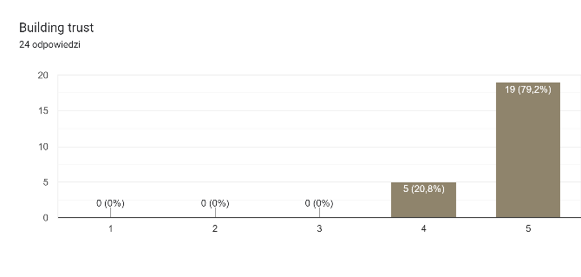 | 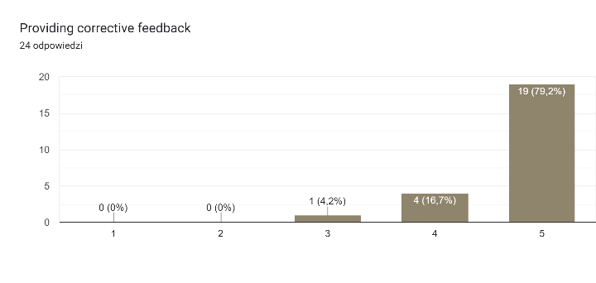
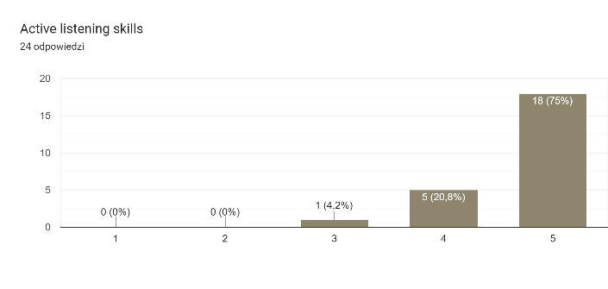 | 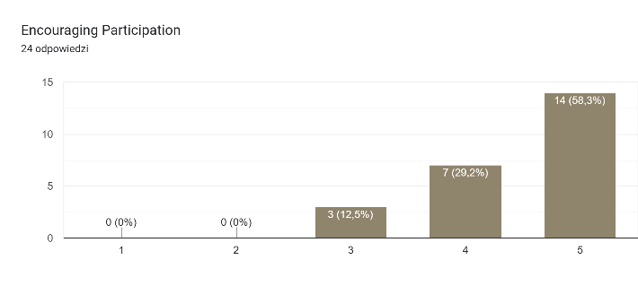

There were other skills consider relevant that were not mentioned in the questionnaire:
- patience, empathy, commitment
- feeling comfortable
- errors are acceptable
- knowing your limits
- openness and not judging
- transfer knowledge and experience
- understand living conditions other than your own
- ability to work in team

While thinking about good relationships between mentors and mentees we should take into consideration also peer mentee’s skills.
According to the data gathered by PRO-MED the following mentees skills are crucial:
- building trust
- listening actively
- showing initiative
- identifying goals and current reality
- encouraging

There were also some more mentees’ skills considered relevant that were not mentioned in the questionnaire:
- blended learning experience
- empathy, patience, curiosity, composure, calm
- knowing your limits,
- the ability to overcome difficulties

What advice would you give to someone who wants to become a peer mentor?
- treat your mentee wisely
- start from knowing your audience
- include an individual, empathic approach for people 50+
- be patient and polite for your mentees
- not expect too much in terms of results and time scheduled
- be yourself and share your passion
- be open and confident that your knowledge and experience can help someone
- remember that often less is more
- explain things in a simple way
- listen without judging and be open-mined
- take yourself patience training
- do not expect too much before you meet your mentee

Being a mentor you should take into consideration mentees’ needs that make them to stay motivated in a peer-mentoring program:
Supporting personal development needs, setting clear goals, enabling supportive environment for learning in a good atmosphere, proposing interesting activities, articulating positive outcomes, ensuring that they have somebody that listens to them, understanding their limitations, developing friendly relationship, offering a variety of topics, celebrating successes of mentees, understanding mentees’ problems, supporting instant cooperation, fulfilling needs for being seriously treated, convincing mentees that the session really makes sense.
Motivation, persistence, faith in the meaning of learning, trusting in the mentor are also important.
Mentees need to receive some kind of direct, immediate "profit".

What specific needs have people 50+ when it comes to peer mentoring?
An individual approach of a mentor addressing individual needs, the feeling of not knowing can be frustrating so we have to remind them that it is ok, age-appropriate learning pace, empathy, patience, tolerance, immediate problem-solving, ability for working with elderly, awareness that using new technologies/tools requires new skills, remembering that 50+ have their own life experience, knowing their priorities as far as subjects are concerned (e.g. they want to know how to communicate with family, friends, how to search for information, how not to fall victim to a scam), starting from clear and calm explanation of what the mentoring session is and what we are going to work on, development of "soft skills" that are useful in modern world, integration with people of similar age, honouring their experience.

Benefits of Peer Mentoring for Mentors and Mentee
5 Benefits of Peer Mentoring for Mentors
1 | The mentor can pass on his/her experience and expertise and demonstrate his/her ability to be an effective teacher
2 | The mentor has increase his/her competences and complete his/her CV with more achievements
3 | The mentor can improve his/her ability for teaching elderly
4 | The mentor can understand limitations of elderly mentees
5 | The mentor can gain awareness that his/her knowledge and experience can help someone

5 Benefits of Peer Mentoring for Mentees
1 | The mentee may get professional advice/resources from a mentor on knowledge/career growth
2 | The mentee has increase his/her competences and complete his/her CV with concrete achievements
3 | The mentee can develop "soft skills" that are useful in a modern world
4 | The mentee can integrate with peers mentors
5 | The mentee can become a mentor in the subject area he/she is an expert

Quiz

1 | Is the statement true or false?  Peer mentoring is a relationship between people who share some similarities (e.g., age), in which one person has more experience and/or different knowledge than the other in a particular domain thus providing learning support for knowledge and skills development.
2 | Is the statement true or false?  To be an effective mentor, you need to have experience in the area you are mentoring someone in along with the ability to read the individual to understand what they need in order to help them choose the right path.
3 | How many ways to become a good mentor are described in this module?  3  5
4 | Is the statement come from 10 principles of Roles of Peer Mentor?  Mentors depart from the point that the mentee is a diamond in the rough that has enormous potential to shine. Thus the mentors journey/purpose is to unearth and passionately inspire the mentee to empower him or herself to manifest this potential.
5 | Is the statement true or false?  Not every situation is a learning opportunity, regardless of the context....so be resourceful!
6 | What advice/advices would you give to someone who wants to become a peer mentor?  - treat your mentee wisely  - start from knowing your audience  - include an individual, empathic approach for people 50+  - be patient and polite for your mentees  - not expect too much in terms of results and time scheduled  - be yourself and share your passion  - be open and confident that your knowledge and experience can help someone  - remember that often less is more  - explain things in a simple way  - listen without judging and be open-mined  - take yourself patience training  - do not expect too much before you meet your mentee
7 | Is the statement true or false?  Mentees need to receive some kind of direct, immediate "profit".
8 | Is the statement true or false?  By being a mentor, you provide a concrete knowledge for mentees, so they can learn from your prior experience and they can make better decisions in similar scenarios.
9 | Which benefit of Peer Mentoring for Mentors is the most important?  - The mentor can pass on his/her experience and expertise and demonstrate his/her ability to be an effective teacher  - The mentor has increase his/her competences and complete his/her CV with more achievements  - The mentor can improve his/her ability for teaching elderly  - The mentor can understand limitations of elderly mentees  - The mentor can gain awareness that his/her knowledge and experience can help someone
10 | Which benefit of Peer Mentoring for Mentee is the most important?  - The mentee may get professional advice/resources from a mentor on knowledge/career growth  - The mentee has increase his/her competences and complete his/her CV with concrete achievements  - The mentee can develop "soft skills" that are useful in a modern world  - The mentee can integrate with peers mentors  - The mentee can become a mentor in the subject area he/she is an expert

11 | Which mentor’s skills are crucial?  - building trust  - listening actively  - showing initiative  - identifying goals and current reality  - encouraging
12 | What kind of mentors’ skills are the most important?  - patience, empathy, commitment  - feeling comfortable  - errors are acceptable  - knowing your limits
13 | Are there any other mentors’ skills which are also important?  - openness and not judging  - transfer knowledge and experience  - understand living conditions other than your own  - ability to work in team
14 | Did you ever try peer mentoring at University of Third Age?  Yes  No
15 | Is the statement below about empathy?  “It is important to relate to your mentees and understand their perspective and feelings. If they are having a bad day, you should pick up on their energy and work to help them through it. You should be able to understand how your mentee is feeling and how to guide him or her.”
16 | Is the statement true or false?  Mentoring is about transformation, only of the mentee.
17 | Is the statement true or false?  Do not allow your mentee to make their own mistakes.
18 | Is the statement true or false?  Mentors do not just provide answers and solutions to all their mentees questions and problems/obstacles. Mentors share the basic components of the learning and thereby encourage their mentees to explore, grow and generate their own ideas and solutions. This process encourages maturity, resilience and independence within the mentee.
19 | Is the statement true or false?  The mentee can become a mentor in the subject area he/she is an expert.
20 | Can you be a mentor?  Yes  No

Literature

- M. MacLean, Mentor training, last opened 2022.10.30, https://www.youtube.com/playlist?list=PLsBOyF4zN1-dMXT_ys8IIwD9l-OfbegKy
- S. Peak, 5 Ways to Become a Better Mentor, last opened 2022.10.30, https://www.businessnewsdaily.com/3504-how-to-mentor.html
- OneUpOneDown, Mentorship blog, last opened 2022.10.30, https://oneuponedown.org/blog/

Annex 1 Quiz Answers

1 | true
2 | true
3 | 5
4 | true
5 | false
6 | a,b,c,d,e,f,g,h,I,j,k,l
7 | true
8 | true
9 | a,b,c,d,e,f
10 | a,b,c,d,e,f
11 | a,b,c,d,e
12 | a,b,c,d,e
13 | a,b,c,d,e
14 | yes, no
15 | true
16 | false
17 | false
18 | true
19 | true
20 | yes, no

