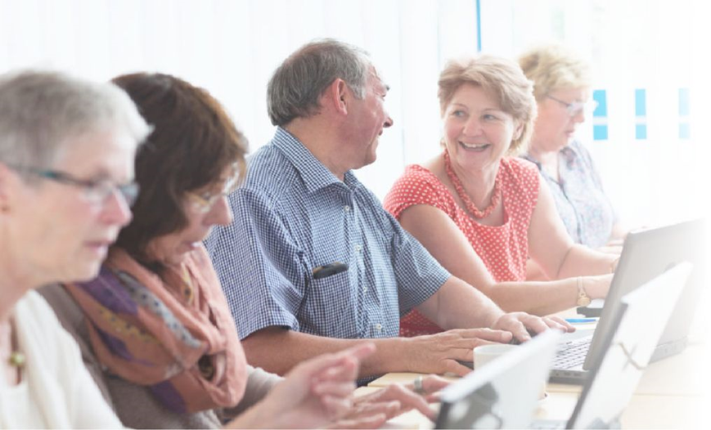

Peer Mentor Training
Peer Mentors of the 21st Century for People 50+
INTERACTIVE PRACTICAL EXERCISES
Strengthening Capacities to Support Active Ageing in the Conditions of the 21st Century - Peer Mentoring Program for People 50+
PEER-TRAIN

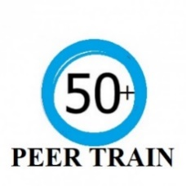
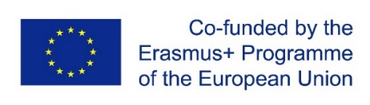
KA2 KA220-ADU - Cooperation partnerships in adult education
Form ID: Form ID KA220-ADU-0F1F5E31
Project Number: 2021-1-DE02-KA220-ADU-000028253
Strengthening Capacities to Support Active Ageing in the Conditions of the 21st Century - Peer Mentoring Program
for People 50+
PEER-TRAIN

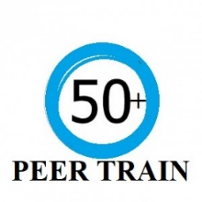

Peer Mentor Training “Peer Mentors of the 21st Century for People 50+”

This publication has been approved by a consortium of partners within the framework of Erasmus+ KA2 project 2021-1-DE02-KA220-ADU-000028253 Strengthening Capacities to Support Active Ageing in the Conditions of the 21st Century - Peer Mentoring Program for People 50+ - PEER-TRAIN.

Main objectives of the project are to contribute to the professionalization of partner organizations, increase the knowledge and develop professional and digital competencies of experts, developing competences of peer mentors for people 50+ in line with the requirements of the 21st century by means of innovative solutions and digital technologies. The project specifically focuses on supporting and developing international cooperation of participating organizations, building, and strengthening partnership networks.

The Peer Mentor Training will focus on increasing key competencies - personal, social, methodological and digital competencies of experts and future peer mentors. By involving well skilled peer mentors who are more acceptable to their peers, mentees 50+ will be more motivated to engage in activities, especially in the field of lifelong learning.

Coordinated by EureCons Förderagentur GmbH and edited by Spoluprácou pre lepšiu budúcnosť - Veľký Meder
November 2022

2021-1-DE02-KA220-ADU-000028253
The European Commission's support for the production of this publication does not constitute an endorsement of the contents, which reflect the views only of the authors, and the Commission cannot be held responsible for any use which may be made of the information contained therein.

