RACHEL ARTHUR WRITES
- Blog
- About Rachel
- Contact
24th Apr 2023
Rachel Arthur
Uncategorized
1 commenton AI Tools for Teachers

AI Tools for Teachers

Overwhelmed by the ever-growing list of AI tools? No need to stress – we’ve done the work for you! Our blog rounds up the latest and greatest innovations, organised specifically for teachers.
Given that around 2000 new AI tools were launched in March alone, it’s nearly impossible for teachers to stay updated on the latest and greatest tools. After all, we want AI to lessen our workload, not add to it with constant innovations. To help, I’ve compiled a list of the best AI tools for teachers, categorised and summarised below. Stay tuned for more blog posts where I will be testing and comparing these tools, but for now, this serves as a landscape review!
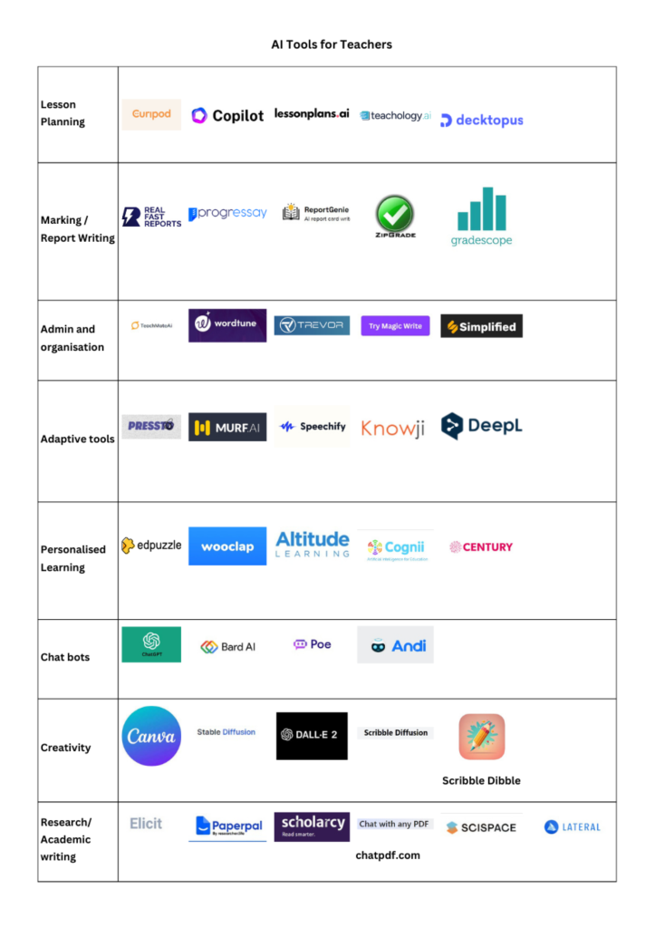
Disclaimer: Please be aware that the list of tools below is not exhaustive and is based on recommendations, online research, and other blogs. I have been given some free trails to access the tools listed and try them out. I will continue to update and expand the list as new tools become available. If you come across any other helpful tools that I may have missed, please do not hesitate to share them with me. Recognising the risks of using AI, bias, copyright, GDPR, and other related policies and procedures is also essential. I highly recommend reviewing my previous blogs on these topics before diving in.
Lesson Planning and slide decks
Writing lesson plans can be so time consuming, but these tools make it easy. Whether you need help developing resources, creating activities, or designing slide decks, these innovative tools will help streamline the process and save you time.
- Curipod – Curipod is an interactive presentation tool for making lessons. You can create your own lessons or use their AI generator to create engaging and interactive lessons and activities.
- Education Co-Pilot Writing lesson plans and handouts can be time-consuming, but this tool makes it easy. Just provide your lesson titles and learning objectives, and it will generate complete plans and handouts for your entire series of lessons.
- Lessonplans.ai is an innovative lesson plan generator designed by teachers, for teachers. Their cutting-edge AI technology streamlines the planning process, allowing you to create high-quality lesson plans quickly and easily.
- Teachology.ai This website offers AI-powered tools for teachers to create and manage lesson plans, assessments, report comments, syllabus documentation, and more.
- Decktopus simply enter any topic into the search bar, select your audience and objective for the presentation and it will make you a slide deck in seconds.
Marking and Report writing
With so much to do as a teacher, marking and report writing can often feel like a chore. However, AI tools can help alleviate some of this burden by automating these tasks. Keep in mind, though, that using these tools may require sharing pupil data, so it’s important to be aware of the risks and follow your school’s policy on data privacy.
- Real Fast Reports – write your reports faster by using this AI driven tool. By writing reports in bullet format, it will create full sentences that have been spell checked and then save them into a comment bank so you can use them again.
- Progressay – Progressay is an award-winning, AI driven, automated essay marking platform it has LMS systems integrated and allows you to mark and moderate pupil work on the platform.
- Report Genie – Quickly write your pupil reports by entering their name, pronouns and selecting feedback from “good” to “poor” against a range of criteria and let it do the hard work for you!
- Zipgrade – multiple choice grading app which automarks assessments done on paper and online and gives you access to class results.
- Gradescope – Automark a range of assessments and questions, then get data and create personalised feedback for each pupil and class – it even marks hand written assessments!
Admin and Organisation
Wish you had a personal assistant to take control and help you with organisation, well these AI tools claim to help you to do that. From diary planning to writing emails – check them out!
- Teachmate.ai – An AI digital assistant offering to simplify and speed up admin tasks.
- Wordtune – An App that helps you to “take your writing to the next level.” You can copy chunks of text in and it will shortern, expand, rewrite or change the tone at the click of a button – making letter writing and emails much faster.
- Trevor – Trevor AI helps you manage your calendar and block time for the tasks you need to complete.
- Canva Magicwrite – An AI text generator embedded into canvas docs to help you to write faster, it will even convert a document to a ppt for you!
- Simplified – Many AI tools rolled into one platform to allow you to write blogs, articles and even simple explanations
Adaptive Tools
We all want our pupils to be able to access our lessons and enjoy the learning but sometimes there are barriers that prevent this, so why not check out these AI tools which are improving pupils access to learning.
- Pressto– AI tool that makes writing fun by creating scaffolds to support pupils to access.
- Murf.ai – powerful voice generator with a range of free to access realistic voices to allow anything to be read aloud to your pupils.
- Knowji – is an app that creates flashcards for key words to support pupils understanding of vocabulary
- DeepL – claims to be the worlds most accurate translation software and could be a great tool for EAL pupils
- Speechify – Text to speech reader, similar to murf ai with some celebrity voices including Snoop dogg and Gwyneth Paltrow!
Personalised Learning
In an ideal world, teachers would have sufficient time to customize every lesson according to the unique needs and interests of each student. However, this is often not the reality! So why not try these AI bots who claim to do that for you…!
- Edpuzzle allows you to edit videos easily and explore the banks of videos other users have created for your subject.
- Wooclap -Helps you to create interactive presentations for your classes. With features such as quizzes and word clouds that your pupils can engage with from their own device.
- Altitude Learning – US based company that provides tools for competency-based education, project-based learning, student assessments, and teacher professional development
- Congnii – US based again but this time combining cognative science and AI to create personalised learning for your pupils
- Century – AI-powered platform that provides personalised learning experiences to students. It uses adaptive algorithms to analyse students’ learning patterns and deliver content and assessments that are tailored to their individual needs.
Chat Bots
With the widespread use of Chat GPT in the news, it’s safe to assume that chatbots need no introduction. Here our some of the ones we found that could be useful for teachers:
- Chat gpt – open AIs chat platform that is now integrated into many other products including Microsoft.
- Bard – Googles chat gpt eqivielant.
- Poe – App based chat bot but this one claims to be faster than all the others!
- Andi – A chatbot designed for children to use, claims to have more guard rails to protect against bias and inappropriate content, so if fully tested could be used in class.
Creativity
Want to inject some more creativity into your lessons? Then look no further than this list of AI tools !
- Canva – free online design software that has some AI powered features, make quick posters and presentations using their range of templates.
- Stable Diffusion – Text to image software that will create any image based on your description or prompt.
- Dall.e – Type in a description of an image and it will create 6 options of images you can use – part of open AIs offerings.
- Scribble diffusion – Turn your sketch into a refined image using AI – I can see many pupils loving this!
- Scribble Dibble – Similar to scribble diffusion but this is an app that allows you to take a picture of a drawing and turn it into a refined image
Research / Academic Writing
Decided to embark on your masters or MPQ journey? Or simply want to stay upto date with the latest subject research? Then these AI tools are for you.
- Elicit – Dont be scared by the name ! This tool allows you to enter your research question and it will suggest articles for you that are relevant from 175 million papers
- Paperpal designed specifically for academic writing it will help you to proof read and redraft your work.
- Scholarcy summarises any article that you need to read into interactive flashcards or quick summary documents to make academic reading faster
- Chatpdf – Allows you to upload a research paper and ask it questions and it will generate responses from the paper!
- Scispace – combines the last two tools by summaring the research papers you upload and allows you to ask them questions !
- Lateral – helps speed up reading by converting your documents into short snippets – like a highlights reel!
With new tools coming out each week I am sure there are many great ones I have missed, drop me a comment below with your favourites!

